OVERVIEW
A literature review is a common genre in many academic fields as well as in the business world. Sometimes literature reviews will be published as a stand-alone document and other times they will be incorporated as one section in a much longer document. The primary goal of a literature review is to “review” what has been said or written about a specific topic. However, this does not mean to simply list or report what people have said. Instead, the author of a literature review has a major role in the paper because it is their job to sort, sift, and synthesize what has been written. This means the various sources should be “integrated” with one another. Rather than move source by source, you should organize your sources by stasis theory.
Your literature review should focus on one VERY SPECIFIC aspect of the broader issue you investigated Major Essay One. As the researcher, it is your job to learn as much as possible about this topic as possible in the time available so that you can apply this new knowledge in our final essay.
The organization of the essay should follow the levels of stasis theory described in our textbook. You should have a section on each level of stasis as well as an abstract and a brief introduction and conclusion. Your goal is to use the sources collected to discuss this topic at each level of stasis. Remember that you should be working to integrate and organize the sources. Ideally, you should discuss at least three sources in every section of the essay (each stasis level) and include at least two paragraphs at this level. The best stasis maps will not only report information at each level of stasis, but also make connections between sources. For instance, are the definitions offered by source A and B similar or different?

REQUIREMENTS

Topic | - A more specific topic than your stasis map
Length | - A literature review of 1500 to 2500 words – about 5 to 7 pages  - Title page/abstracts/references don’t count
Outside Sources | - At least eight total sources  - At least six scholarly journal articles  - At least one source of public survey data
Citations/Format | - APA Style citations and document design
Spacing | - Double
Font | - Times New Roman 12
File type | - MS Word or PDF (no .pages)

GOOD EXAMPLES
- These are both excellent. However, they are more broad in focus than yours should be. Students in this semester wrote their stasis map first and focused on a whole dimension of wellness. Yours should be more zoomed in on a particular subject.
  - Good Student Lit Review #1
  - Good Student Lit Review #2.docx

The primary organization for this essay should be the levels of stasis. You may even want to include headings that clearly identify where each level of stasis begins. In the table below, I’ve provided some sample topics you might discuss at each level of stasis. Prior to analyzing the topic by stasis level, you may wish to offer a one-two paragraph introduction offering some basic information and facts about the topic.
Your goal should be writing at least two paragraphs and citing at least three sources at every level of stasis. However, the ultimate balance and emphasis of your paper will depend on the sources you collect. I will use the first line of our class rubric “Purpose and Class Concepts” to assess you in two ways.
- Did you understand the stasis level and place the information in the right section
- How much did you include in each section – the goal is at least 3 sources and 2 paragraphs

Possible Stasis Connections

Definitions and Facts
- What are the important concepts and terms in this discussion?
- What measurement systems or diagnostics are used?
- What definitions do most researchers agree about?
- What definitions are controversial or disagreed about?
- What choices do students make now? What choices are they faced with?

Cause and Effect
- What are the causes of a choice or behavior?
  - Which causes do researchers agree about?
  - Which causes do researchers disagree about?
- What are the effects of a choice or behavior?
  - What effects do researchers agree about?
  - What effects do researchers disagree about?
- What questions do researchers have about causes and effects of these choices or behaviors?

Evaluation
- What is the scope or extent of the problem?
  - What do different researchers think about this?
- How much better will things be if students make this choice or engage in this behavior?
  - What do different researchers think about this?
- How difficult is it for students to make the right choice or engage in a good behavior?
  - What do different researchers think about this?
- Are certain groups or people responsible for helping students make the right choices?
  - What do different researchers think about this?

Proposal
- What behaviors should students engage in? What choices should they make?
  - How should they do this? How often should they do this?
  - What do different researchers think about this?
- How should people and organizations help or encourage students to make the right choice?
  - What do different researchers think about this?

The Burkean Parlor
Kenneth Burke, a leading scholar of human communication, writes:
Imagine that you enter a parlor. You come late. When you arrive, others have long preceded you, and they are engaged in a heated discussion, a discussion too heated for them to pause and tell you exactly what it is about. In fact, the discussion had already begun long before any of them got there, so that no one present is qualified to retrace for you all the steps that had gone before. You listen for a while, until you decide that you have caught the tenor of the argument; then you put in your oar. Someone answers; you answer him; another comes to your defense; another aligns himself against you, to either the embarrassment or gratification of your opponent, depending upon the quality of your ally's assistance. However, the discussion is interminable. The hour grows late. You must depart. And, you do depart, with the discussion still vigorously in progress.
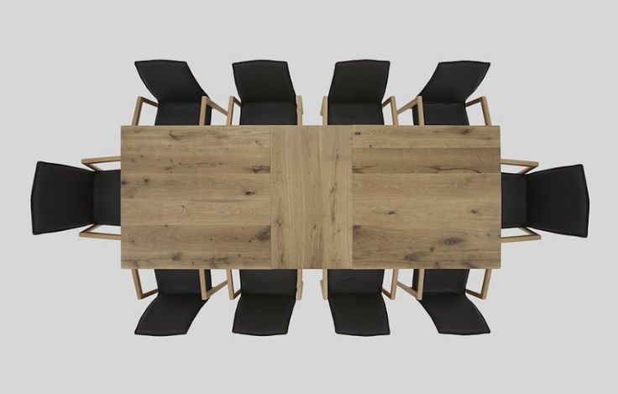
When writing my own literature reviews, I often find it useful to imagine the scholars I am reading seated together at dinner. Ideally, you want to find scholars who already know one another. If the sources you are reading are not citing one another or talking about very similar topics and concepts, you have not yet found the “conversation.” Once you do find that conversation, it is important to begin considering whether there are alliances, factions, or disputes within it. Who would sit near one another? Who would sit far apart? Who would sit at the head of the table? Perhaps there are two leading plans or approaches to this problem, perhaps three. Part of your job in the literature review is to identify these patterns and relationships and explain them to your reader.
In a literature review, your job is not so much to provide “facts” or “information” about a topic. Instead, your focus should be on describing the state of knowledge about this topic at present.
- What is known?
- What is agreed upon?
- What is disagreed about?
- What questions remain to be answered
R.A.F.T.S.
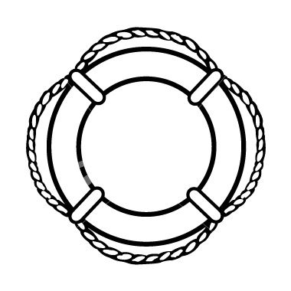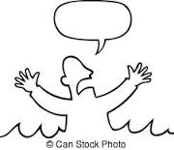
HELP!!!!
Role | - Unbiased, well-informed, and reliable expert  - Curious, diligent, and ethical research
Audience | - The authors you are citing  - Researchers hoping to learn about this field quickly and easily  - Yourself, but at the beginning of the class.
Format | - Literature Review – examine real world examples  - Organized primarily stases NOT by source  - APA citations and document design
Task | - Provide an overview of the current scholarship on a particular topic  - Identify points of agreement and disagreement among scholars  - Identify gaps in our current knowledge on the topic  - Apply stasis theory to help organize and guide your review
Style | - Impartial and direct – no first person and little passive voice  - A mix of summary and paraphrase - quoting to let scholars speak for themselves  - Careful and effective attribution and citation

T.I.P.s
(Task’s Intriguing Problems)

- Find the true discussion and debate on the topic – where scholars speak to one another.
- Identify the key issues among the field at each point of stasis.
- Present both sides of a disagreement fairly even if you agree with one side personally.
- Write in a way that is useful and informative for both experts on the topic and novices
- Explore the issue deeply rather than looking for simple answers and solutions
- Read each source thoroughly and work to integrate and synthesize between sources.

